Assignment 26.3

Problem Statement:

Use real_estate to solve queries.

Link: Real_Estate.csv

● Create table RealEstate in Hive database, with all the columns present in dataset.

● Load dataset into table realEstate.

● Using Dynamic partition get separate lists of residential apartments with more than 2 beds and include columns in following order City,Baths,Sq_feet,Price,flat_type,Beds respectively.

RealEstate table created and dataset loaded in it.

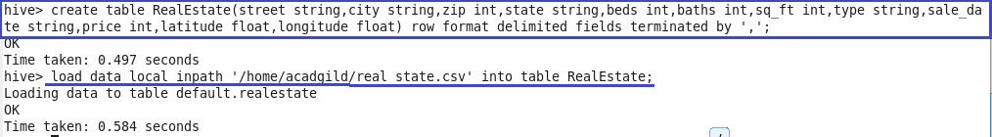

Partition table Residential is created for the given query.



Data copied into residential partition table for residential apartments with beds>2.

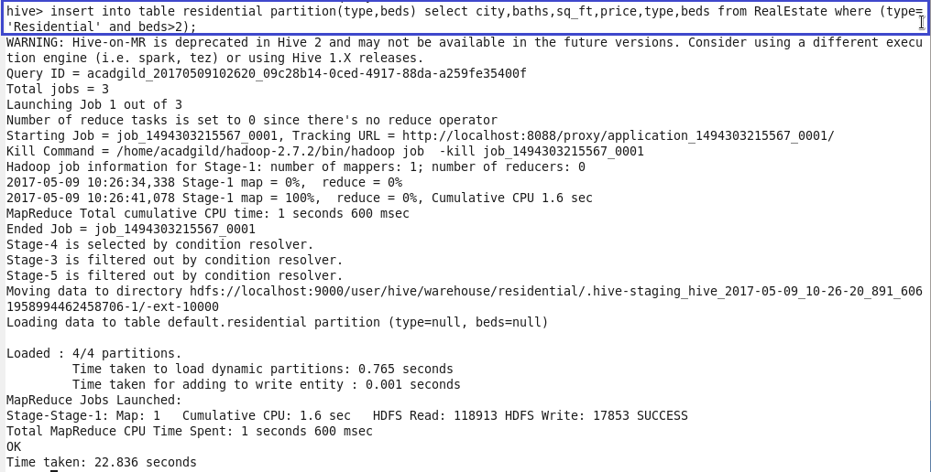

Sample Output displayed from the residential partition directory with beds=3 created in hdfs.

